December 6, 2012

Dear Ms. Charlyne Chen,

I am leading a delegation to the U.S. and planning to visit Las Vegas, Nevada on the10^{th &} 11th of December. I would like to visit the State Government of Nevada, University of Nevada, Las Vegas, and cultural creative industry. Please assist us in organizing and facilitating the tour. Your kind assistance is greatly appreciated.

Thank you in advance.

Best Regards,
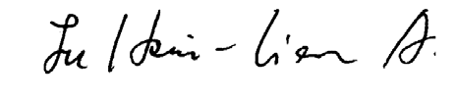
Former Vice President of Taiwan 2000-2008

