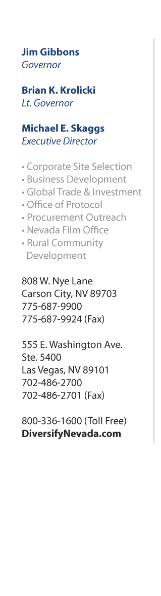
Mr. Feng Guoping
Director, China Textile Human Resource Exchange & Training Centre
Room 201, Tower B HuaYe International Center , No. 39
Dongsihuan Zhonglu, Chaoyang
Beijing, 100025
Peoples Republic of China

Dear Director Feng:

The Nevada Commission on Economic Development wishes to welcome you and your delegation to visit the MAGIC Show in Las Vegas during the weeks of August 15 and 22, 2011. We also wish to invite your partner, Info 21 Data Media Group, to participate with you in your visit to Las Vegas during this time.

We understand that your Council is in the process of organizing a delegation of 20-25 large Chinese textile manufacturers and exporters to explore the possibility of investing in a China Textile Center in Las Vegas. During the time of your visit we wish to discuss in detail the potential establishment of a China Textile Center in Las Vegas. As soon as you have identified the members of your delegation please let us know and we would be pleased to send you a formal letter of invitation, including each member of your delegation, for the purpose of using this invitation in the process of each member of the delegation obtaining a visa to visit us in the U.S.

Out of the approximately 39 million visitors Las Vegas currently receives every year about 8 million are business buyers who come to trade shows seeking to source products. With a China Textile Center in Las Vegas you will have all of the textile buyers coming to you from around the world and many of these would not get to China to visit your manufacturing companies. Las Vegas has been very successful in becoming the new furniture and home furnishing market, formerly in Highpoint, North Carolina, with the introduction of the World Market Center, http://www.lasvegasmarket.com/ . The same type of business could easily develop for the textile industry.

In addition, Nevada has:
- no personal income tax, no corporate profits tax or inventory tax
- excellent distribution capabilities to the Western US and especially to California, the 7th largest GDP in the world
- A Foreign Trade Zone in the Las Vegas area where, if you can turn pieces of product or raw materials into final product (repackaging) you can delay payment of duties at the part until you ship the product in the US or pay no duty if the product is exported to anther country.
- Ready access to buyers who come to the MAGIC shows every year

Sincerely,

Alan Di Stefano
Director, Global Business Development

