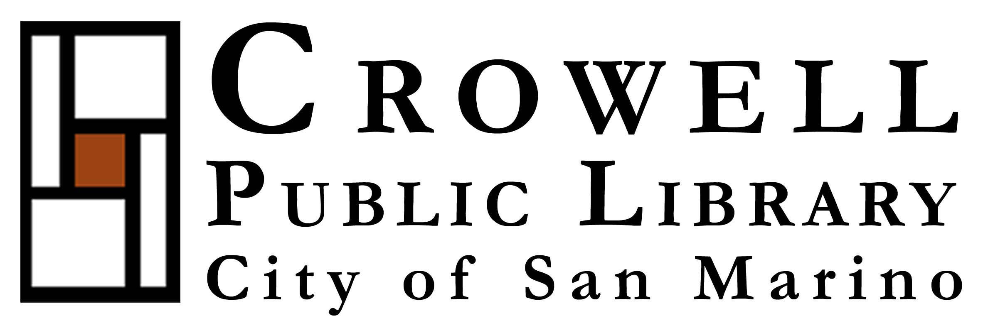
1890 Huntington Dr. San Marino, Ca. 91108-2595
Authors’ Festival
Saturday, January 26, 2013
1:00 pm – 4:00 pm

The Crowell Public Library will be celebrating its 5th birthday here in this beautiful building along with the City of San Marino’s Centennial year by hosting a Birthday Celebration on Saturday, January 26, 2013.

There will be many events that day, including the first “Authors’ Festival” in which 10 to 15 authors will be invited to autograph their published works.

Doris Yu (蓬丹)is the only author who writes in Chinese among the guest writers during this event.

Hope you can join her at this meaningful function to show your support to the community.

聖瑪利諾市立圖書館慶祝建市百年，舉辦第一屆作者簽書會，
女作家蓬丹應邀參加

時間: 2013年1 月26日(星期六)下午1-4時
地點: Crowell Public Library, 1890 Huntington Dr. San Marino, Ca. 91108
電話: (626)300-0777

加州聖瑪利諾市是巴頓將軍的故鄉，於1913年建市，至今恰好一百年，已發展成一環境優美、規劃良好之理想社區。為慶祝建市百年，特於建成剛滿五年之克羅威爾圖書館舉辦紀念活動，活動之一為隆重推出的「第一屆作者簽書會」，邀請約十五位作家展示其作品，並至現場為購買作品的讀者簽名。定居洛杉磯的女作家蓬丹是唯一受邀的華文作者，她將介紹十二部作品集及甫於2012年出版的《丹心如玉》一書。

歡迎各界踴躍參加，以壯華人聲勢。

